Connect to Work West Yorkshire – Delivery Partner application.
This document provides a comprehensive list of all questions asked in our Connect to Work Partner application. The form is split into sections and includes a mix of information only and scored questions. This document does not provide applicants with content and scoring criteria for the scored questions – please refer to the guidance for applicants document where this information is provided in detail.

Part 1 – Information Only
No questions for partners to answer. This page provides an overview of who Better Connect are and the Connect to Work Opportunity.

Part 2 – Organisation Details
If you are an organisation that is named on Better Connect's Approved Delivery Partner list and your information is up to date, the number of questions you will be required to answer will be reduced as we already hold this information on file.
Asked to all applicants:
- Organisation Name
- Main Contact Name
- Main contact email address
- Have you worked with Better Connect before (Yes/No)
- Is your organisation on the Better Connect Approved Delivery Partner List (Yes/No)
- Please confirm your organisational information is up to date (Yes/No) – only asked if the answer to question 5 is Yes.
The next questions are only asked if your organisation is not on our APL or you are on our APL and your information is not up to date.
- Organisation Address
- Organisation Phone Number
- Organisation website
- Please tell us a little bit about your organisation (250 words Max)
- Please provide your Company Registration Number (if applicable)
- Please provide your Registered Charity Number (if applicable)
- What is the legal status of your organisation?
- What date was your company registered?
- Are you VAT registered?
- Please provide your VAT registration number (only asked if Yes has been answered for Q15)
- What size organisation are you?
Asked to all applicants:
- Please confirm which district your organisation is based in (single choice)
- Where is your organisation based? (Only asked if ‘Based outside of West Yorkshire’ has been selected for Q18).
Part 3 – Policies and Assurances
The questions in this section have been designed to help us assess whether organisations can deliver services safely, legally, consistently, and in line with Connect to Work expectations. We recognise that organisations will have different levels of organisational maturity and infrastructure. We are committed to a proportionate approach to assurance requirements and encourage applications from VCSE and community-based organisations. Where policies are still developing, Better Connect can provide support where required during programme mobilisation.
Asked to all applicants:
- From the list below, please confirm which of the following policies/assurances your organisation has in place. Please selected all that apply (multiple choice).
- Please confirm which insurances your organisation currently holds. Please select all that apply (multiple choice)
- Who is your organisations named Data Protection Officer (DPO)
- Who is your organisations designated Safeguarding Lead (DSL)
The questions below are only asked if your organisation is not on our APL or you are on our APL and your information is not up to date.
- Is your organisation registered with the Information Commissioners Office for processing or intending to process personal data? (Yes/No)
- Please provide your ICO number (only asked if Yes is answered to Q5)
Asked to all applicants:
- Is your organisation cyber essentials accredited? (Yes/No)
The question below is only asked if your organisation is not on our APL or you are on our APL and your information is not up to date.
- Please provide detail of any quality standards/marks your organisation holds that would be relevant to the delivery of Connect to Work.

Part 4 – Due Diligence
This section has been designed to ensure that your organisation is both eligible and suitable to receive Connect to Work funding and deliver the provision.
Asked to all applicants:
- Is your organisation in a state of insolvency, voluntary administration, compulsory winding up and receivership, composition with creditors, company voluntary arrangements or subject to equivalent proceedings? (Yes/No)
- Please explain what measures have been taken to demonstrate your reliability despite the existence of relevant and potential grounds for exclusion (only asked if Yes has been answered to question 1)
- Have you or any person who is a member of your administrative management or supervisory body; or has powers of representation, decision control in the organisation been convicted of any of the following:
- Child labour and other forms of trafficking human beings
- Corruption
- Other offences that could prevent your involvement in the delivery of Connect to Work
- Participation in a criminal organisation
- None of the able
- If you have selected any of the offences above, what measures have been taken to demonstrate your reliability despite the existence of relevant and potential grounds for exclusion? (Only asked if anything other than ‘None of the above’ have been selected for Q3)
- In the last 3 years have you
- Been found guilty of grave professional misconduct?
- Been involved in the distortion of competition?
- Breached environmental law obligations?
- Breached social law obligations?
- None of the above
- If you have selected any of the questions above, what measures have been taken to demonstrate your reliability despite the existence of relevant and potential grounds for exclusion? (Only asked if anything other than ‘None of the above’ have been selected for Q5)
- Are there any conflicts of interest you wish to declare? (Yes/No)
- Please provide details of any conflicts of interest (only asked if ‘Yes’ is selected for Q7)
- Have there ever been performance issues relating to previous contracts or grants that you have been awarded? (Yes/No)
- Please explain what measures have been taken to demonstrate your reliability despite the existence of relevant and potential grounds for exclusion (only asked if ‘Yes’ has been selected for Q9)

Page 5 – Organisational Track Record
This section has been designed to help us understand your track record of delivering employability support. For the scored questions, please ensure you refer to the completion guidance provided by Better Connect - this will inform you of the content and criteria used to score these questions.
Asked to all applicants:
- Are you currently delivering structured employability provision in West Yorkshire? (Yes/No)
- Please provide a summary of the provision you are delivering and where it is being delivered (only asked if ‘Yes’ is selected for Q1) 300 words max.
- How are you predominantly delivering this provision? (single choice) – only asked if ‘Yes’ is selected for Q1.
- Are you currently delivering (or have you delivered in the past) IPS provision? (Yes/No)
- Please provide details of this provision. (only asked if ‘Yes’ answered to Q4)
- Do you have a fidelity rating for IPS delivery? (Yes/No)
- Please provide details of the project this rating is in relation to and when it was awarded – only asked if ‘Yes’ has been selected for Q6)
- How would you rate your knowledge and/or experience of delivering IPS provision? (1 – 5)
- Please provide a rational for the rating provided. (SCORED QUESTION 500 words max)
- Do you consider your organisation to be locally embedded in West Yorkshire communities? (Yes/No)
- Please provide details below (SCORED QUESTION 500 words max – only asked if ‘Yes’ is answered to Q10)
- How do you intend to embed your organisation into West Yorkshire Communities to deliver Connect to Work support? (SCORED QUESTION 500 words max – only asked if ‘No’ is answered to Q10)
- Please provide 2 relevant programme/contract examples that supports your organisations ability to meet the requirements of Connect to Work (table).

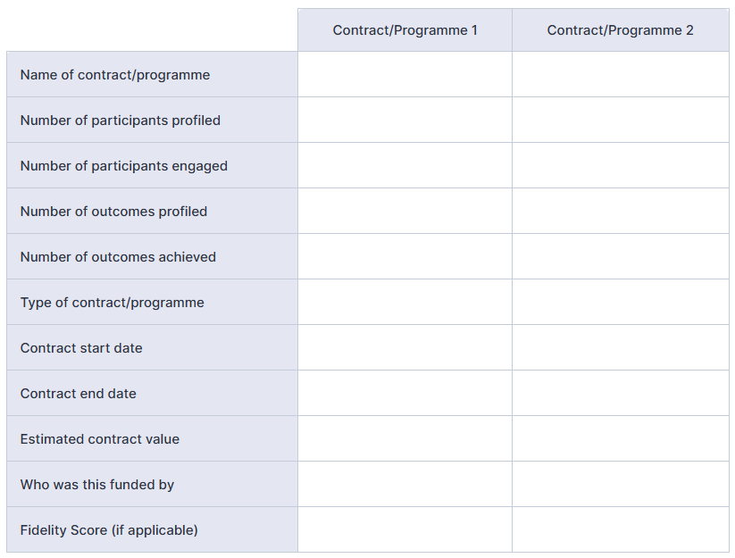

Part 6 – Connect to Work Delivery
This section has been to capture what your organisation would like to deliver within this Connect to Work partnership. It will help us to assess your organisations capabilities for delivering Connect to Work. For the scored questions, please ensure you refer to the completion guidance provided by Better Connect - this will inform you of the content and criteria used to score these questions.
Asked to all applicants:
- Please indicate from the list below, which priority groups your organisation will engage through Connect to Work. Select all that apply.
- Ex-offenders (someone who has completed a custodial or community sentence)
- Offenders (someone who is service a community service)
- Carer or ex-carers
- Homeless
- People for whom a drug or alcohol dependency, including a history of, presents a significant barrier to employment
- Former members of His Majesty’s (HM) Armed Forces (AF)
- Partners of current or former Armed Forces personnel
- Refugees, resettled Afghans or resettles Ukranians
- Victims of domestic violence
- Young people identified as being involved or at risk of being involved in gangs or serious violence
- Victims of modern slavery
- Disabled people, who have a disability or long term health condition.
- How and why have you identified this/these cohorts to support through Connect to Work? (SCORED QUESTION – 500 words max)
- If successful, which district will your Connect to Work delivery take place? Please select all that apply.
- Please indicate where in the district(s) identified above that delivery will take place. (SCORED QUESTION - 500 words max)
- Please indicate in the table below the number of Connect to Work participants you anticipate working with. Please note you will only be asked to complete a table for the districts selected in Q3.

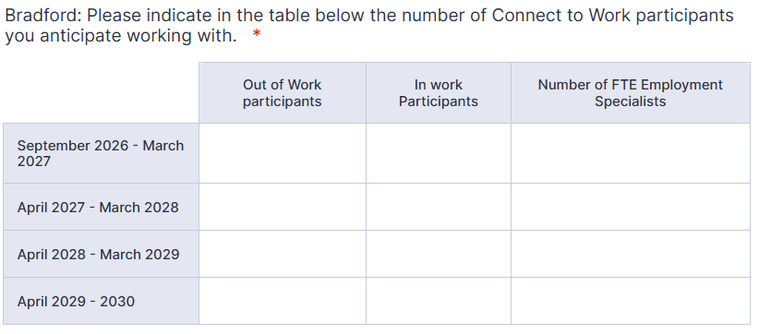
- Please indicate in the table below the number of staff/roles your organisation will dedicated to delivering Connect to Work. Please note these are in addition to the FTE Employment Specialists detailed in the table(s) completed in Q5.
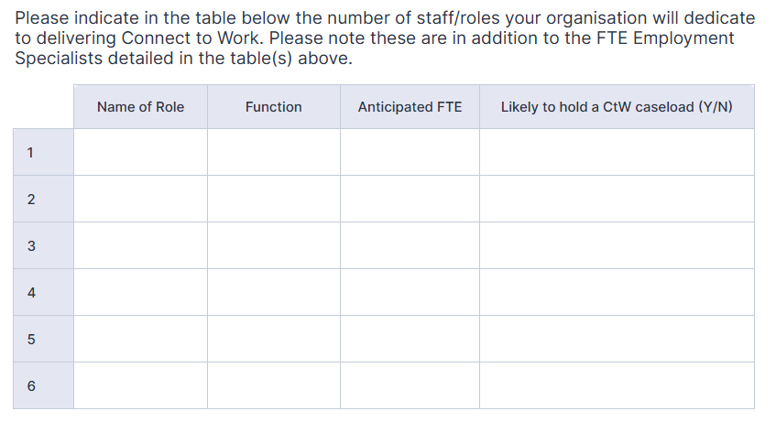

- Will you need to recruit for staff resource to deliver this programme? (Yes/No)
- How many staff will you need to recruit? (only asked if ‘Yes’ is answered for Q7)
- Please upload the staff details spreadsheet using the Better Connect template provided.
- Please confirm you are able to provide in person Connect to Work support (Yes/No).
- How do you intend to triage potential participants, ensuring they are referred into the right type of employability support? (SCORED QUESTION – 500 words max)
- Describe your approach to delivering the Supported Employment Model. Ensure all 5 stages of the model are included in your answer. (SCORED QUESTION – 1000 words max).
- With which sectors do you have strong employer links with? (Multiple choice)
- Please describe you approach to employer engagement and support offered to employers specifically in relation to Connect to Work West Yorkshire. (SCORED QUESTION – 500 words max)
- Please describe your approach to coordinating access to integrated health and other support services. (SCORED QUESTION – 500 words max)

Part 7 – Organisational Compliance
In order to be included in the Connect to Work partnership, we must be confident that you are able to meet the monitoring requirements as requested by Better Connect, West Yorkshire Combined Authority and the DWP. Better Connect will provide you with the tools you need to complete monitoring and will provide information and support where it is required. For the scored questions, please ensure you refer to the completion guidance provided by Better Connect - this will inform you of the content and criteria used to score these questions.
Asked to all applicants:
- Please confirm using the list below that you are able to provide the financial information required to evidence spend on this project - tick all you are willing to provide. (Multiple Choice)
- The Connect to Work payment model has not yet been confirmed, please confirm which payment model options are manageable for your organisation. Please select all that apply. (Multiple choice)
- How will you ensure compliance with fidelity? (SCORED QUESTION – 500 words max)
- Social Value Contribution: Please describe how your organisation currently contributes or proposes to contribute to social value through the delivery of Connect to Work IPS support. (SCORED QUESTION – 500 words max)

Part 8 – Declarations and permissions
By confirming the statements below, you are providing assurance that your organisation is both eligible and suitable to be considered for delivering IPS provision for Connect to Work West Yorkshire.
Asked to all applicants:
- Name of the person completing this form
- Declarations
- Application declaration – please upload your completed form (template provided by Better Connect), this may be required to be included with Better Connects submission to WYCA for Connect to Work West Yorkshire.
- Signature

